Section for Network 2

Network details

1. Nodes:

8xDevices
4xPCs
2xSwitches
1xRouter
1xISP connection
1xServer

2. Type:
LAN (connected to a WAN through a ISP ).

3. Topology: Star.
On the network there are wired types of transmission.

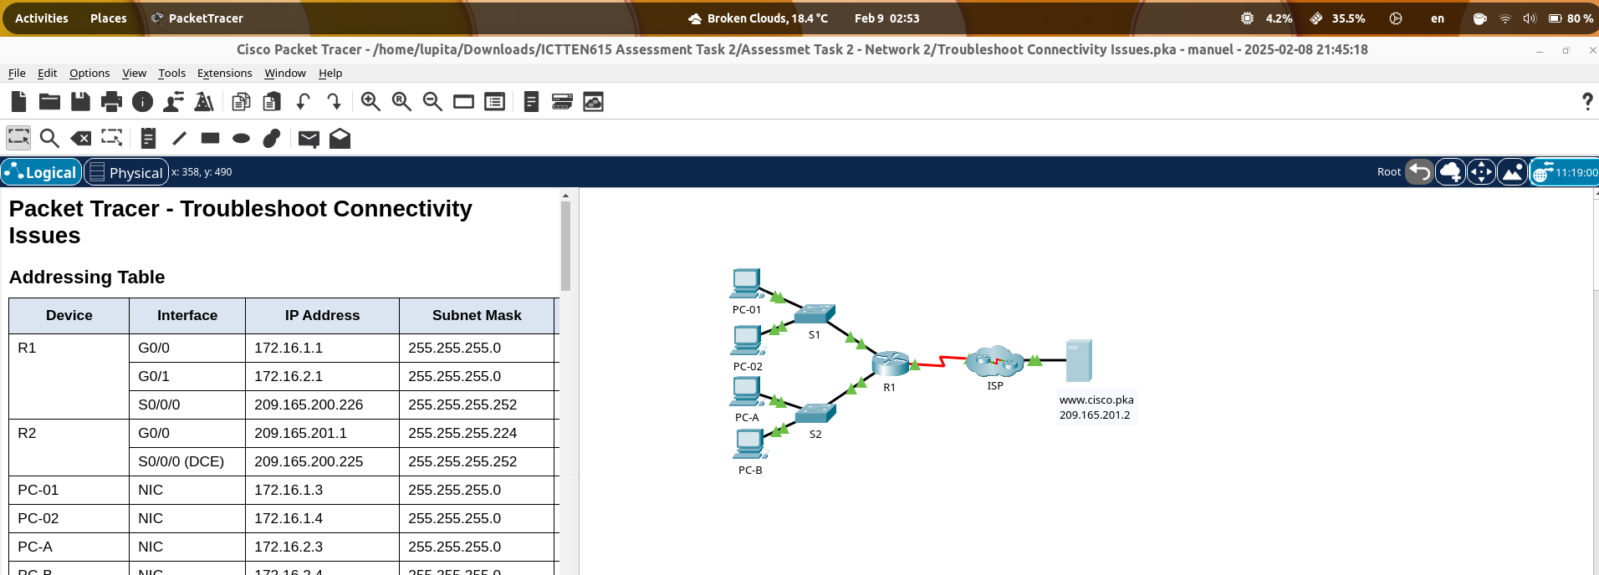
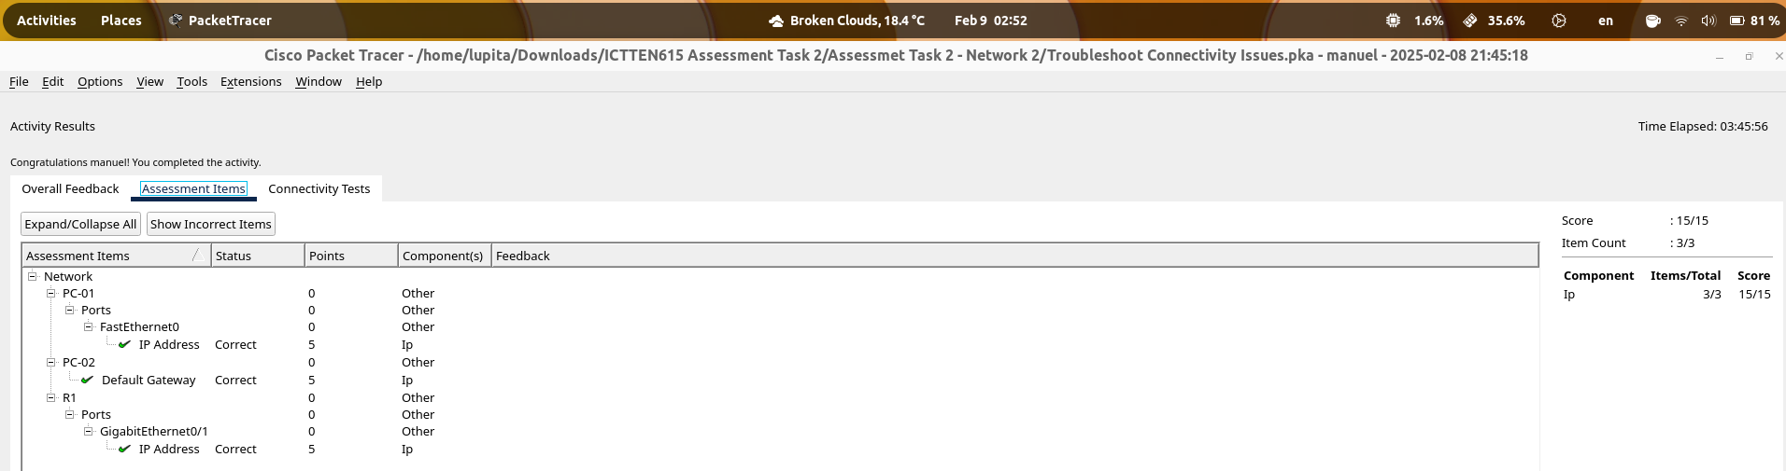

Work details

Scope
- Evaluate current network performance and identify traffic congestion issues.
- Develop and implement solutions to optimize traffic flow.
- Monitor the implemented changes and adjust configurations as needed.
- Ensure network security and improve user experience.

Complaints
Users report slow internet speeds and delays in accessing cloud storage.

Identified Issue
High network congestion during peak business hours due to excessive streaming and large file transfers.

Planned Network Strategy:

• Segment the network by creating VLANs to separate employee and guest traffic.
• Implement Quality of Service (QoS) policies to prioritize critical applications.
• Upgrade bandwidth allocation based on usage patterns.
• Enhance network security by introducing access controls and authentication measures

Budget Available:
- The project must be completed using existing infrastructure with minimal additional costs.
- Any upgrades must be justified with performance improvement data.

Site Access Arrangements & Timelines:

- Access credentials will be provided for simulated network management tools.
- Students will need to log in to designated platforms for network configuration.

Implementation

VLAN networks for employee and guesst.
- CLI Switches are not accesible, customer did not provide password si it is not possible to implement with the existing infrastructure.

In conclusion, it is no possible due to budget limitations.

Recommendations
1. Provide CLI Switches passwords
2. Reemplace Switches

Legislation
Workplace Health and Safety Act 2011code:
As part of the IT team, I am required to follow legal guidelines for the management of electronic equipment and networks such as cabling and racks. As part of my duties, I must maintain and make modifications to the physical infrastructure of the TechCorp Solutions's network.

Code od conduct
Telecommunications Code of Practice 2018:

As a service provider to TechCorp Solutions, I will ensure that I provide accurate, detailed information and fair pricing.

Regulations
Workplace Health and Safety Regulations 2021:

As a service provider to TechCorp Solutions, I will ensure that I attend to the client's safety training as well as comply with the Incident Reporting policy. In particular, my regular duties involve following Electrical Safety regulations.

Standards
Customer service standards:

As a service provider of TechCorp Solutions, I will ensure that I offer the highest standard of service as well as follow the same quality standard in after-sales services.

Network monitoring software
- Wireshark – for packet analysis.
- Cisco Packet Tracer – for network simulations

Network capacity and traffic congestion evaluation

System alerts/alarms

- Network R1
  - Issues from PC-01: Not connected to the network
  - Issues from PC-02: PC-01 and devices on Network R2 are unreachable
- Network R2
  - Issues from PC-A: Web server and devices on Network S1 are unreachlable
  - Issues from PC-B: Web server and devices on Network S1 are unreachlable

Screenshots – test

Network R1 – PC-01
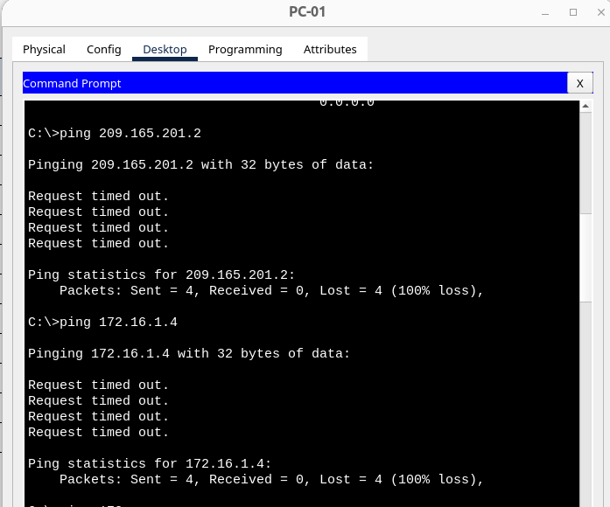

Network R1 – PC-02
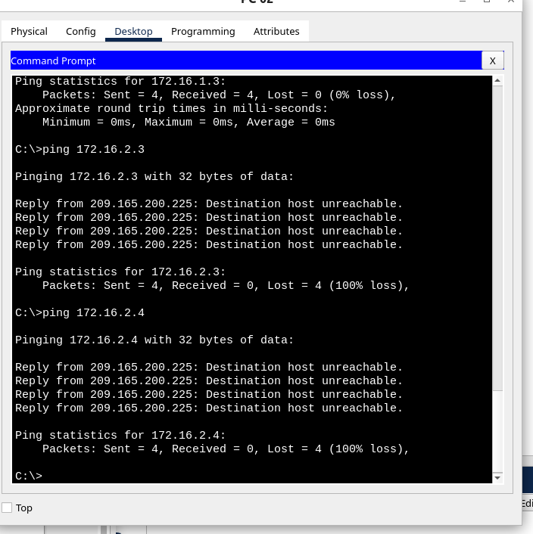

Network R2 – PC-A
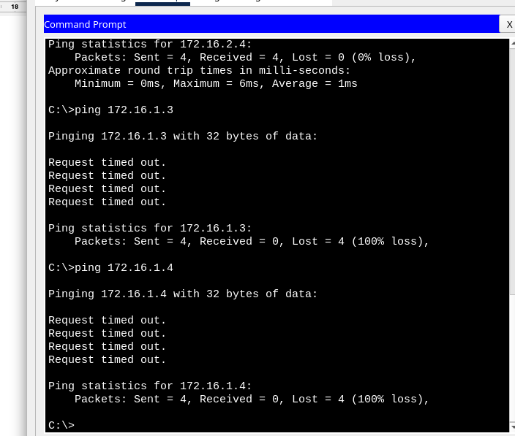

Network R2 – PC-B
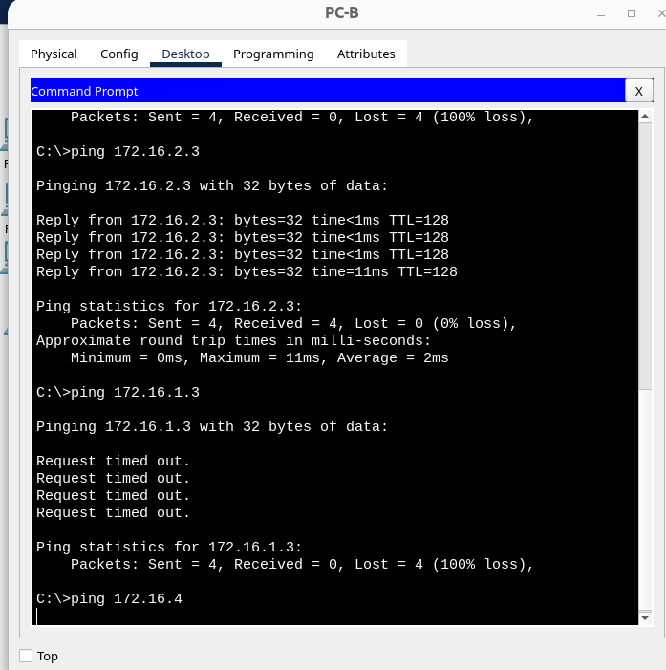

Network traffic measurements

There are several connectivity problems on the network:

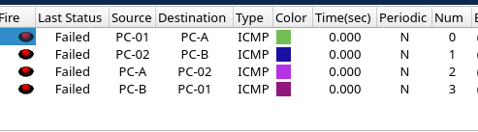

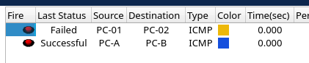

Traffic problems (potential or real).

- End user Devices coud have wrong IP configuration
- Router and Switches could have wrong IP configuration
- The network is not segmented correctly

Network outages (planned/unplanned)

their extent and duration and how long it took to restore the network

Network problems

Connectivity issues from PC-01.

Ping to default gateway (172.16.1.1): Timeout
To web server (209.165.201.2): Timeout
To PC-02 172.16.1.4: Timeout
To PC-A 172.16.2.3: Timeout
To PC-B 172.16.2.4: Timeout
access www.cisco.pka: Host Name Unresolved
209.165.201.2: Host Name Unresolved

Connectivity issues from PC-02.

To PC-01 172.16.1.3? Timeout
To PC-02 172.16.1.4? Timeout
To PC-A 172.16.2.3: unreachable
To PC-B 172.16.2.4: unreachable

connectivity issues from PC-A.

To web server (209.165.201.2)? Timeout
Ping to default gateway (172.16.2.1)? Timeout
To PC-01 172.16.1.3? Timeout
To PC-02 172.16.1.4? Timeout
Can PC-A access www.cisco.pka? Unresolved
Using the web server IP address 209.165.201.2? Unresolved

Connectivity issues from PC-B.

To web server (209.165.201.2)? Timeout
Ping to default gateway (172.16.2.1)? Timeout
To PC-01 172.16.1.3? Timeout
To PC-02 172.16.1.4? Timeout
Can PC-A access www.cisco.pka? Unresolved
Using the web server IP address 209.165.201.2? Unresolved

semi-permanent controls

Throttling controls were used with the following settings:

1. GPRS connection
2. Regular 2G connection
3. Regular 3G connection
4. Regular 4G connection
5. Offline

Network analysis

- On PC-01 Wrong Ip address gatweay 172.168.1.3
- On PC-02 wrong Ip address gateway 172.16.1.11 to 172.16.11
- The connection are broken between R1 and C1/C2, also between R1 ab cisco server.
- On R1 port G01 172.16.3.1. is seted up the wrong IP, the correct one is 172.16.2.1

Network analysis - Summary results

1. Incorrect IP Gateway on PC-01:

Issue: PC-01 has the wrong cIP gatweay onfiguration: it is set to 172.168.1.3.
Impact: This could prevent PC-01 from properly routing traffic to local network..
Resolution: Set up the IP gateway on PC-01.

2. Incorrect IP Gateway on PC-02:

Issue: PC-02 has the wrong cIP gatweay onfiguration: it is set to172.16.1.11.
Impact: The same issue as the PC-01, the incorrect gateway will prevent PC-02 from routing to local network.
Resolution: Update the gateway on PC-02 to 172.16.1.1 to ensure proper routing and network access.

3. Broken Connections Between R1 and C1/C2, and R1 and Cisco Server:

Issue: Connectivity is broken between Router R1 and both C1/C2.
Impact: This disruption affect critical parts of the network, affecting access to other devices and cloud services
Resolution: Check for interface status and configuration.

